SMART BILL BOARDS USING IBM WATSON

OBJECTIVE:

A **billboard** is a large outdoor advertising structure , typically found in high-traffic areas such as alongside busy roads. The largest ordinary-sized billboards are located primarily on major highways, expressways or principal arterials, and command high-density consumer exposure (mostly to vehicular traffic). These afford greatest visibility due not only to their size, but because they allow creative "customizing" through extensions and embellishments.

The **purpose** of **billboards** is to create awareness. They are effectively used to broadcast the services of your business. There are lots of **billboard** in the highways. Billboards ads come in many different shapes and sizes and occupy those huge boards either side of the motorway.

HARDWARE COMPONENTS:

MODULE 1:-MICROCONTROLLER

1.NODEMCU:

NODEMCU is an open source LUA based firmware developed for ESP8266 WIFI chip. By exploring functionality with ESP8266 chip, NODEMCU firmware comes with ESP8266 Development board/kit i.e. NODEMCU Development board.

Since NODEMCU is open source platform, their hardware design is open for edit/modify/build.

NODEMCU Dev Kit/board consist of ESP8266 WIFI enabled chip. The **ESP8266** is a low-cost WIFI chip developed by ESPRESSIF Systems with TCP/IP protocol.

NODEMCU Dev Kit has **Arduino like** Analog (i.e. A0) and Digital (D0-D8) pins on its board.

It supports serial communication protocols i.e. UART, SPI, I2C etc.

Using such serial protocols we can connect it with serial devices like I2C enabled LCD display, Magnetometer HMC5883, MPU-6050 Gyro meter + Accelerometer, RTC chips, GPS modules, touch screen displays, SD cards etc.

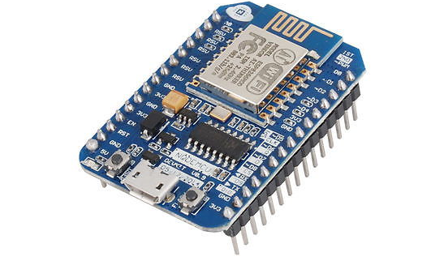

MODULE 2:-Basic Board

a)LIGHT EMITTING DIODE(LED):

A **light-emitting diode** (**LED**) is semiconductor lightsource that emits light when current flows through it. Electrons in the semiconductor recombine with electron holes, releasing energy in the form of photons. This effect is called electroluminescence. The color of the light (corresponding to the energy of the photons) is determined by the energy required for electrons to cross the band gap of the semiconductor. White light is obtained by using multiple semiconductors or a layer of light-emitting phosphor on the semiconductor device.

LEDs have many advantages over incandescent light sources, including lower energy consumption, longer lifetime, improved physical robustness, smaller size, and faster switching. Light-emitting diodes are used in applications as diverse aviation lighting, automative lightings advertising, traffic signals, camera flashes, lighted wallpaper and medical devices.

b)SWITCH:

 A **switch** is an electrical component that can "make" or "break" an electrical circuit, interrupting the current or diverting it from one conductor to another. The mechanism of a switch removes or restores the conducting path in a circuit when it is operated. It may be operated manually, for example, a light switch or a keyboard button, may be operated by a moving object such as a door, or may be operated by some sensing element for pressure, temperature or flow. A switch will have one or more sets of contacts, which may operate simultaneously, sequentially, or alternately. Switches in high-powered circuits must operate rapidly to prevent destructive arcing and may include special features to assist in rapidly interrupting a heavy current. Multiple forms of actuators are used for operation by hand or to sense position, level, temperature or flow. Special types are used, for example, for control of machinery, to reverse electric motors, or to sense liquid level. Many specialized forms exist. A common use is control of lighting, where multiple switches may be wired into one circuit to allow convenient control of light fixtures.

MODULE 3:-DISPLAY

OLED:

An **organic light-emitting diode** (**OLED**) is a  LED in which the emissive electroluminescent layer is a film of organic compound that emits light in response to an electric current. This organic layer is situated between two electrodes; typically, at least one of these electrodes is transparent. OLEDs are used to create digital displays in devices such as television screens,computer monitors, portable systems such as smartphones and PDAs. A major area of research is the development of white OLED devices for use in solid state lighting applications.

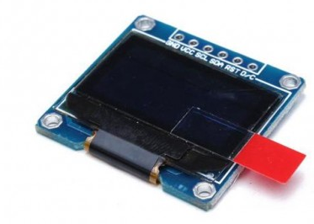

An OLED display works without a backlight because it emits visible light. Thus, it can display deep black levels and can be thinner and lighter than a liquid crystal display (LCD). In low ambient light conditions (such as a dark room), an OLED screen can achieve a higher contrast ratio than an LCD, regardless of whether the LCD uses an light backlight.

MODULE 4:

a)IBM CLOUD:

IBM offers three hardware platforms for cloud computing. These platforms offer built-in support for virtualization. For virtualization IBM offers IBM websphere application infrastructure solutions that support programming models and open standards for virtualization.

The management layer of the IBM cloud framework includes IBM Tivoli middleware.[]](https://en.wikipedia.org/wiki/IBM_cloud_computing#cite_note-IBM_middleware-2) Management tools provide capabilities to regulate images with automated provisioning and de-provisioning, monitor operations and meter usage while tracking costs and allocating billing. The last layer of the framework provides integrated workload tools. Workloads for cloud computing are services or instances of code that can be executed to meet specific business needs.[[4]](https://en.wikipedia.org/wiki/IBM_cloud_computing#cite_note-Dummies-4) IBM offers tools for cloud based collaboration, development and test, application development, analytics, business-to-business integration, and security.

b)NODE-RED:

**Node-RED** is a flo -based development tool for visual programming developed originally by IBM for wiring together hardware devices-APIs and online services as part of the Internet of things.

Node-RED provides a web browser- based flow editor, which can be used to create Java-script functions. Elements of applications can be saved or shared for re-use. The runtime is built on Node-js. The flows created in Node-RED are stored using JSON. Since version 0.14 MQTT nodes can make properly configured TLS connections.

**It** is a programming tool for wiring together hardware devices, APIs and online services in new and interesting ways. It provides a browser-based editor that makes it easy to wire together flows using the wide range of **nodes** in the palette that can be deployed to its runtime in a single-click.

ARCHITECTURE:

The use of Smart boards has widely increased these days. The applications that can be developed using these smart boards have been increasing day-by-day. Smart billboards can also target motorists on the highway or pedestrians passing bus shelters. Companies can attract the customers by doing advertisements. These smart bill boards will help them in attracting their customers and make their task easier. In this we can upload the required data on the bill board simply by giving inputs through user interface. And we can check the lamps working status which is connected to bill board through the UI.

Through device we can select the mode of the display and according to the selected mode we can change the data on the display. the data can be entered through user interface which is created in Node Red. We can get the status of the lamps which are connected to the bill boards in the user interface. If any lamp fail we can send notifications to authorities.

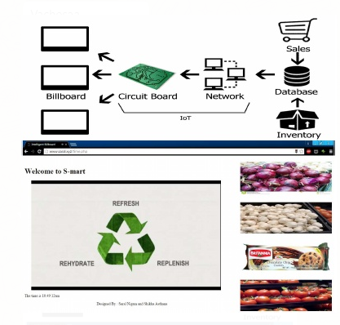

FUTURE SCOPE:

Advertisements, regardless of their form, are engineered to accomplish one thing: capture the attention of an onlooker and inspire action.

In the past, the advertising industry predominantly used mediums such as newspapers, billboards, television, and the radio to deliver their marketing messages. These “traditional” mediums have received a few face lifts over the years in the form of digital outdoor advertising, as well as more advanced printing and broadcasting methods that increased their fidelity.

Recent technological innovations, however, have led many big players in the advertising industry to go back to traditional forms of advertising, specifically digital billboards and their smaller screened counterparts. Why? Because unlike online ads, billboards are not seen as being an inconvenience; in some cases, billboards are even seen as “artistic”, especially those put into the public’s eye by companies like Apple and Coca Cola.

**Billboards** are a great way to reach the masses – to reach where they live, commute, work and socialize. Unlike other mass advertising media such as TV or radio ,**billboards** can't be switched off. Or with magazine print advertising, it can't be put down.

CONCLUSION:

We have concluded that thus this bill boards need not be regularly monitored so it reduces the human efforts.